**Mrs. Zeinert**

room #D100 [terrydreiszeinert@hasd.org](mailto:terrydreiszeinert@hasd.org) (920) 779-7900 x 14100

**Welcome to Art I**

**ART I** serves as an awareness and experimentation of various mediums. The purpose of this class is to develop an appreciation of **visual art forms** as we **create** it and as we **observe** it: in nature, architecture, media, clothing design, and much more.

Art I is a semester class; our goal is to build a foundation of drawing & painting skills, while incorporating the Elements and Principles of Design. The implementation of the Elements and Principles of Design will; strengthen visual art creation, it become the vocabulary necessary to talk about artwork, and how to respond to artwork of others through critiques.

After the successful completion of Art I, you may take other art classes including; Drawing, Painting, Fibers, Printmaking, Ceramics, Art Metals, and Sculpture.

**SUPPLIES:**

* ***You will need to bring***; **2 Ultra fine point sharpie markers, a** box of **Tissues,** and space on a **Flash drive**
* Youwill receive an ART KIT that will contain supplies to use throughout the year. Supplies are returnedat the end of the year. **Lost supplies and broken plastic boxes will need to be replaced.** We will have most items available for purchase if you need replacements.
* I would like you to keep an **art shirt** or cover up in your locker. Many of the supplies we use will stain your clothes.
* 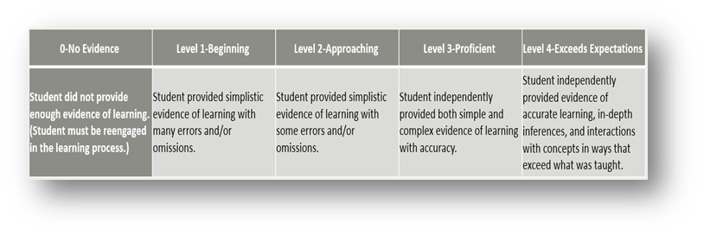**Misuse of art room materials will require payment for replacement**; supplies are shared with many - Art I classes.

**Standards Based GRADING:**

* We will be using a 4-point scale

Which will then be converted to a letter grade

for a semester grade; based on an **average**

* Proficiency is based on a body of evidence.
* Proficiency is organized and reported on

learning target rubrics.

* Students will have multiple opportunities to demonstrate

# **EXPECTATIONS:**

* **Daily class work and weekly art journal pages** are part of this class. Ample class time is provided to complete work. If you choose not to manage time wisely, you will need to complete coursework out side of the classroom.
* **Cell Phones** If your phone becomes a distraction anytime throughout the semester; during instruction, work time and you are not turning in quality work because of it, I will collect your phone every day for the period until the work needed is done.
* **Handbook and School policy** Students are to follow rules and guidelines that are found in your Student Handbook.
* All work must demonstrate **effort**, **completion, name identification** & **turned in** for grading in designated area.

I will not search the classroom to find your work

* The room must be kept **clean**; you are responsible for cleaning your table and supplies, including putting them away. There is no eating or drinking during a class period; unless otherwise instructed. Inappropriate behavior and language will be disciplined. You must sign-out to leave the room. You are expected to be in class on time. Tardiness will result in loss of daily privileges. Proper Safety Procedures MUST be followed always. ALWAYS work safely. Unsafe operation of equipment or horseplay will result in removal from class.

proficiency, which may include reassessment.

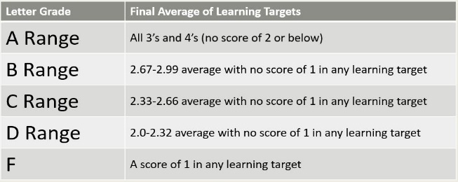

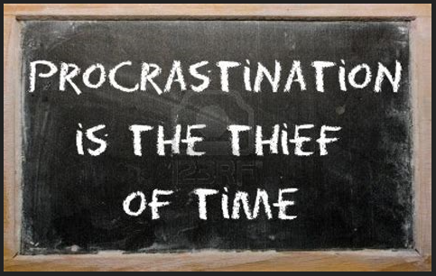

**… and may result in failure**

(Continued on the back)

j0199100**ART I STUDENT CONTRACT**

* Student has elected Art I with the understanding that they will use their **class time to work**

**on assignments**; excessive **socialization will hinder satisfactory scores**.

* Student will display an attitude of **respect** for teacher and peers.
* Student understands that they must be **attentive during instruction time** for a clear understanding of assignment expectations.
* Student is responsible for **completing and submitting all assigned work**; no assignment is optional.
* Student is responsible for submitting work to the assigned location for each project.
* Student is responsible for **asking questions** if they do not have a clear understanding of an assignment.
* Student is responsible **viewing all class handouts** provided. They are resources for generating ideas and successfully completing all assignment.
* Student understands that visual art is a process of **careful thinking and problem solving**.
* Student realizes that **submitted work must be appropriate**, determined by the discretion of the teacher.
* Student realizes that they **may improve their score** on each assessment after first completing the **Request to retest or improve** form.
* Student will **leave cell phones** in designated **basket** when leaving the classroom during class ( i.e.: to go to the bathroom, Office….)
* Student **will not use or look at cell phones during class presentations**, if seen by the teacher they will be taken away for the day. If you are on Facebook, YouTube, Games, Twitter, Tumblr, Instagram or your phone; and it has become a distraction…..You will receive a minor referral.
* **Parents and students** need to remember to only **access cell phones; before/after school, during lunch, and between classes**.
* **Extra credit is not an option for missing projects**.
* Absences do not eliminate assignments. You are responsible for making-up work due to absence.

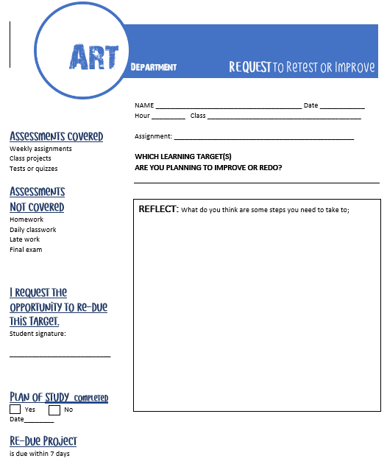

**I, _________________________________________________**

**(please print), understand and will abide by all class expectations.**

**Students Signature_________________________________________**

**Parent/Guardian**

**Signature_____________________________­­­­_____ Date _­­_______**

**Hortonville High School Behavioral Standards**

**UNITED**

**A.S1**: Students will communicate and collaborate with others to accomplish tasks and develop solutions to problems and opportunities.

**RESPECTFUL**

**B.S1**: Students will identify and apply employability skills.

**B.S2**: Students will use technology appropriately to further their learning.

**ACCOUNTABLE**

**C.S1**: Students will formulate and defend judgements and decisions by employing critical thinking

**Retest or Improvement policy**

Students have the privilege to improve assignments, class projects, or retest

* When they are current with all work
* Have filled out the Blue request form-

using the assessment rubric to identify how they will make improvements

* Have completed re-assessment within 7 days

Assessments that may not be improved:

Daily class work, late work, final exam

(Continued on the back)